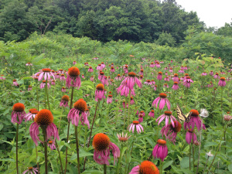
Trail Breathing
A trail is not like other spaces. Trees surround, sway over, and create an invitation to move forward. Sometimes that is just what my husband and I need to reconnect after a long week. Slowly walking up the steep incline of the East Pinnacle Trail in Berea, heartbeats are quicker and more pronounced. We pause at the top of the initial assent and sip water before moving on. Pauses are powerful reminders to be present and let go of the constant reflection and contemplation of the future. I fall further into tranquility with this pause and begin the next step with heightened awareness.
This is just one of the trails in the Indian Fort Mountain Trail network and our favorite. The trail meanders more softly and allows easy breath to return. I notice Chris stopping to look at a small white wildflower as I continue to plow on. The movement upward brings us to a fork in the trail and a field of bright pink coneflowers. Also called Echinacea, it is often used as a natural treatment to boost immunity. Standing among so many, I feel their healing power. Fuchsia petals surrounding the bright orange center contrast against the field of green leaves and trees. We remember our first date to this same spot, same time of year, and same blooms. No matter how our lives move on, this spot is a gentle reminder that we can return to the roots of our relationship and reconnect with the excitement of those first experiences.
Climbing higher among boulders covered with moss, the trail reaches several lookout points. Walking to the edge of a bolder, the overlook allows views of green pastures and farmland in Berea. We sit and bask in the brief sunlight breaking through the thick clouds. For the moment we are at peace and can breathe together.

